

AUGUST 2026 AV 5786/ELUL 5787
Phone: 254-772-1451 Fax: 254-772-2471
Email: cajassistant@grandecom.net Website: www.agudathjacob.org
Rabbi Ben-Zion Lanxner President Jeff Levin
cajrabbi@grandecom.net levin@grandetx.com

From the Desk of
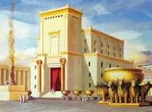
Rabbi Ben-Zion Lanxner

"When will The Messiah come?"
That has always been the million-dollar question
For more than 3000 years, Jews have eagerly anticipated the arrival of the Messiah.
I Believe that Today Is the Time!
We are living in very precarious and chaotic times, to say the least. Whereas only three years ago the world and the people of Israel were optimistic about a peaceful solution to the Middle East conflict, today that optimism has been replaced by pessimism, fear, anxiety and depression, no viable peaceful solution is in the near future…
Even, with the U.S. continuous and relentless bombardments on Iran and its IRGC and Ayatollahs, with no regime change in the horizon, the world is still in a dangerous and unprotected situation.
Fear of unbridled and senseless terrorism, and depression from what appears at this particular moment, to be a no-win situation for the State of Israel, as long as the US Administration is “in charge” of making the decisions (and putting the State of Israel’s citizens security in harm’s way, with the “so called” Peace Agreement and the Gaza complete disarmament and total eradication which seems as of even today after so many months of “Negotiations” a utopia, to say the least!).
Now, more than ever before, over the last 50 years (after 1967’s Six-Day War), the Jewish people, and even the entire world, need The Messiah, a Savior and a Redeemer.
We need someone who can, somehow, bring about more than just a tenuous ceasefire between two warring peoples.
{We need someone who can, once and for all, bring an end to all human conflicts, especially in the Middle East, but also in Europe with the invasion and Islamization of every country in continental Europe, which is by no means “peaceful” but a takeover and forcefully submitting people to this “Evil and Satanic Ideology” (Sharia Law) either by converting to Islam or be killed in the name of Allah.
If we consider Europe already lost, we, here in the United States of America are NOT so much better off, seeing how Islamists Imams are inciting their people to impose “Sharia Law” into the USA}.
And, if he can do that -- a tall order -- then perhaps he would also be able to destroy whatever other evil exists in the world.
As he engineers this long-dreamed-of world peace, let him make unethical and immoral behavior a thing of the past, too.
In other words, this Messiah, if he is truly the awaited Savior, should usher in a permanent utopian society where virtuous living is the main theme and second- (if not first-) nature.
So, what shall we call this modern-day hero of Biblical proportions?
In Judaism, he has always been called "The Anointed One"– "The Mashiach"-- because, as a Jewish King he is to be anointed upon taking office, so-to-speak. (The Mashiach concept has been adapted into other religious societies and is known in English as the Messiah.)
The centrality of Mashiach and the belief in his eventual arrival is part-and-parcel of Jewish belief, as Maimonides emphasized in his classic "Thirteen Principles of Faith":
I believe with perfect faith in the coming of Mashiach, and even though he may tarry, nevertheless, I will wait for him every day, that he will come. (Principle #12)
-- and a promise from the prophets:
The smallest shall become a thousand, and the least, a mighty nation. I am the Lord, in its time, I will hasten it. (Isaiah 60:22)
According to tradition, the prophet Isaiah was referring to the future arrival of the Redeemer of the Jewish people -- Mashiach ben David – Mashiach, a descendant of King David, from the tribe of Judah (Yehudah). There are many similar references to his eventual arrival in the Jewish Bible and subsequent commentaries, and this is one of the most-discussed concepts in Torah literature.

The subject of the “Messianic Era or the “Coming of the Messiah is examined in the Talmud Tractate Sanhedrin on pages 97a-99a, with occasional tangents for related topics.

Here, I will hit just a few of the high points but there is much more to be found in those pages.
On page 97a, a number of Sages share their opinions as to what the world will be like prior to Mashiach’s arrival. Rabbi Yochanan says that Mashiach will come in a generation when Torah scholars are decreasing, the people are in despair, and afflictions just keep on coming without a break.
Rabbi Nehurai says that Mashiach will come in a generation when young people are “Chutzpadik” (disrespectful) to their Elders and those Elders honor the young. Daughters disgrace their mothers, daughters-in-law humiliate their mothers-in-law, and sons feel no shame in front of their fathers.
The Sages say that Mashiach won’t come until things are so bad that the people have despaired of redemption altogether.
Of course, many of these things have come to pass and Mashiach has not yet come because our sins delayed his arrival. Alternately, HaShem’s attribute of strict justice (as opposed to His attribute of mercy) is delaying Mashiach’s arrival.
If this is the case, the Talmud asks, why should we even bother waiting for him? Andi it answers that we wait for Mashiach because doing so earns us a reward as per Isaiah 30:18, “Happy are all those who wait for him”.
The Sage known as Rav says that all the scheduled times for Mashiach to arrive have already passed; the only things that can bring him now are Teshuvah (repentance/return) and performing Mitzvot. His counterpart, Shmuel, says that the suffering the Jews endure in exile will be sufficient to do the job even if the Jews do not repent.
Rabbi Nosson expounds on Habakkuk 2:3: “The vision is reserved for the appointed time; it declares the end and does not lie. Though it tarries, wait for it because it will surely come and will not delay”.
This verse, he tells us, “Penetrates and descends to the depths”.
That is to say, just as the extent of the depths are unknowable, so too the date of Mashiach’s arrival is an impenetrable mystery.
Rabbi Abba thinks that the time of The Messiah’s arrival is obvious, based on Ezekiel 36:8, “But you, mountains of Israel, will shoot forth your branches and yield your fruit for My people Israel because they are coming soon”. (This, of course, already happened when the Jews returned to the Promised Land in 1948, with the founding of the Sovereign and Independent State of Israel.)
Rabbi Yochanan said that if you see a generation beset by afflictions that are relentless like a river, you should expect that Mashiach is coming soon. This is based on verses in Isaiah chapter 59. Verse 19 says that “distress will come in like a flood, driven by the breath of G-d.” Verse 20 continues, “And a redeemer will come to Zion….”
Rabbi Yochanan also said that Moshiach will only come either in a generation that is totally innocent or one that is totally guilty. “Totally innocent” is based on Isaiah 60:21, “Your people will all be righteous; they will inherit the land forever”. “Totally guilty” is based on several verses, including Isaiah 48:11, in which G-d says, “I will do it for My Own sake”.
Rabbi Joshua Ben Levi pointed out an apparent contradiction in Isaiah 60:22. The verse says, “I will hasten (Mashiach’s arrival) in its time”.
Which is it? Will He hasten it, meaning He will make it happen quickly, or will it happen in its assigned time? He reconciles the conflict as follows: if the Jews are worthy, G-d will hasten the redemption. If we are not, it will come about at the designated time.
Of course, there are also those Talmudic authorities who discourage thinking at all about when Mashiach is coming.
Rabbi Shmuel bar Nachmani actually cursed those who try to calculate the time of Mashiach’s arrival.
This is because such people end up causing a decrease in other people’s faith. They name a time and, when Mashiach doesn’t adhere to their timetables, those who accepted the prediction assume he must never be coming.
Ultimately, it’s up to us to bring The Messiah. Rabbi Joshua Ben Levi asked Eliyahu HaNavi (the prophet Elijah) when Mashiach would arrive. Elijah said, “He’s sitting at the city gate – go ask him yourself!” So, Rabbi Joshua found Mashiach and asked him, “When are you coming?” “Today,” Mashiach replied.
Rabbi Joshua was excited by this news but he was subsequently disappointed when Mashiach didn’t show up as expected.
He complained to Elijah, who explained that Rabbi Joshua had misunderstood Mashiach’s meaning. What Mashiach meant was Psalms 95:7, “Today, if you will just listen to His voice!”
To appreciate the importance of Mashiach's arrival, one must first appreciate that the Jewish people are in exile, as we have been for thousands of years. This is true even with the present-day State of Israel; "exile" from a Torah perspective can occur even when the Jews are living in Israel, as was the case during the Greek Exile (319-139 BCE) which ended with the miracles of Chanukah.
In other words, "exile", from a Torah-perspective, is defined as "anything short of a complete and perfect Torah society living on the Land of Israel under the leadership of Mashiach".
That will be a time when all nations will accept the existence of HaShem, the G-d of Israel, and the need for return and total devotion to Him.
Until this becomes an absolute reality, exile will still be a primary theme of Jewish history.
On the one hand, and from a non-Torah perspective, events in the Middle East today may be reason for grave concern but are not necessarily a " Gateway “to significant change in the spiritual quality of society and mankind. From this perspective, the only hope is that somehow the situation will find rectification, Tikkun, so that the lives of those affected can return to more of a "normal" subjective term defined by each individual and society.
On the other hand, and still from a non-Torah (secular) viewpoint, the concept of "The Messiah" and a spiritually utopian society may be burdensome, even to be feared and avoided, since its goals are so radically different.
Indeed, the yearning for The Messiah is usually appreciated only once a person gains a deeper understanding of Torah, its values, and HaShem's master plan for creation and humanity.
So, the million-dollar question has always been, "When will The Messiah come?" To that end, calculations have been made throughout history -- obviously without success. As well, false Messiahs have popped up all over the world throughout history, sometimes to no effect, sometimes causing great despair, and sometimes leaving whole new religions in their wake.
The Talmud in Tractate Sanhedrin 98b speaks of two possible dates for the arrival of Mashiach, one is the early date, and one is the last possible moment. Bringing Mashiach "early" means, for the most part, national repentance to the ways of Torah, (Teshuvah) after which the rest of the world will fall into line.
However, should the Jewish people avoid a return to Torah, then history will be allowed to run its "natural course “until the time that HaShem pre-destined from creation for it to end.
And “ending” it must, for creation has much bigger goals to accomplish than we have seen until now. As the Sages say: "This world is but a corridor to the next world "Ethics of our Fathers-Pirkei Avot 4:16”.
The first thing to know is that history will last only 6,000 years (Talmud Tractate Sanhedrin 97a). This is because the six millennia are based upon the six days of creation, as hinted to in the first verse from the Book of Genesis where the first Hebrew letter of the Alphabet is found six times, concluding that “Aleph” without vocalization as shown in any Torah Scroll, can also be read “Eleph” meaning a “thousand”.
בראשית ברא א-לו-הים את השמים ואת הארץ
And not only that, but could also be inferred in the following verse cited in Psalms 90:4,
For one thousand years in Your [G-d's] eyes are but a day that has passed.
-- which, in turn, are spiritually rooted in the Six Sefirot (in Kabbalah, or Jewish mysticism).
...This is why so much time must transpire from the time of creation until the time of the tikkun (i.e., Mashiach's coming). All the forces of Gevurot are rooted in the Six Sefirot -- Chesed, Gevurah, Tifferet, Netzach, Hod, Yesod -- which are the six days of creation... and also the 6,000 years of history that the world will exist. And within [the six Sefirot] are the roots of all that will happen from the six days of creation until the Final Tikkun... We find that all that transpires, is the result of the sparks from the time of Tohu vaVohu, Chaos...
This is why events happen in history as they do, when they do. Just like physical DNA determines much of our direction in life, so too, spiritual DNA influences the direction of history for that particular millennium.
As we read in the Book of Genesis, in the first 1,000 years of humanity, the Divine trait of Chessed (Kindness) gave people long lifespans, though they didn't deserve it (Adam lived up to 930 years of age, Enoch lived up to 980 years of age).
In the second millennium, Gevurah (Strength/Judgment) brought down Divine justice on mankind through the Flood and the dispersion from the Tower of Babel.
Tiferet (Beauty) made Torah possible in the third millennium, the time of Abraham and Moses. And so on...(Just to clarify a little bit of the meaning of these Sefirot, they are in other term, the channels by which the “Infinite” spirituality of HaShem is entering and manipulating the physical world of materialism, our world here on earth, which is actually the whole purpose for HaShem to bring his Shechinah (Heavenly Olam ha-Atzilut) into the world (Down here on Earth in Olam ha-Assiyah), basically bringing Heaven to Earth, G-dliness into Humanity).
Today in 2026, we are in the year 5787 from creation, 213 years until Year 6000 -- the end of "This World".
This represents slightly less than four percent of all of history as we are used to it. However, though this information in and of itself may not create a sense of urgency, a lot is meant to happen within this remaining thin slice of time, part of which may be already affecting the direction of events around the world, particularly those relating to the Jewish people, the Return of the Exiles (proof is The Sovereign State of Israel). Am Israel Chai!
(END OF PART 1)
(In short, if we want Mashiach to come, we should stop talking about it so much and actually do something about it!)
Rabbi Ben-Zion Lanxner

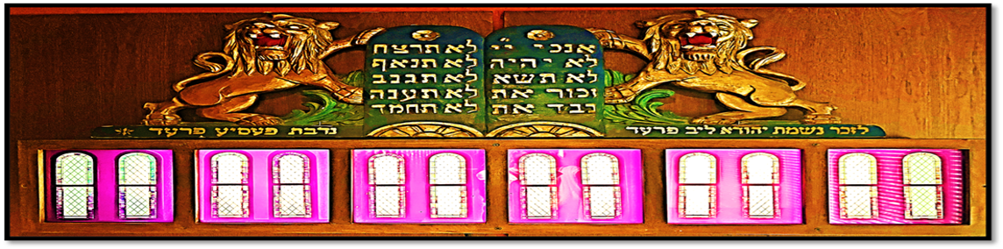

PRESIDENTS MESSAGE

As we prepare for the High Holy Days and dedicate ourselves to a month of reflection and introspection about the course of our lives, here is a useful question to ask ourselves: What is the essence of Judaism? In other words, what is the sine qua non of a leading a religious Jewish life? What is expected of us as Jews?
Our tradition has an answer for this, and it consists of three commitments: to G-d, to Torah, and the Israel. I doubt that this answer would constitute much of a surprise to those of us living active Jewish lives in a religiously observant synagogue community. Yet there are those among people of Jewish heritage who, sadly, reject belief in G-d, reject the Torah and observance of the mitzvot, and condemn and act ashamed by the existence of Israel, our eternal homeland. What does the Torah say about such unfortunate Jews? In the words of the Prophet Isaiah: “Woe unto them that call evil good, and good evil” (Is. 5:20, JPS).
But rather than wasting energy here disparaging or looking down on these misguided brothers and sisters of ours, let us instead look at the joy, the simcha, of a life revolving around devotion to these three things.
Through regular worship, whether private prayer or participating in services at shul, we express our emunah, our faith in G-d, and cultivate a deep sense ahavat Hashem, or love of the L-rd, which can be such as source of ashrei, or happiness.
Through taking time to study the teachings of our greatest rabbis, especially their commentaries on the Torah and other works in the rabbinic canon, we are inspired to perform mitzvot, both “vertical” (pertaining to the sanctification of our relationship with G-d) and “horizontal” (pertaining to our relations with our fellow Jews and other people).
Through praying for, supporting (including financially), and standing up for Israel, including countering the lies that we may hear spoken about our homeland, we can share the love that we feel in being proud Zionists.
As we get our neshamot ready to experience renewal during the High Holy Days, let us never let go of a feeling of gratitude for these great gifts that we have received from Hashem: His divine presence in our lives and in our world, His Torah and the body of mitzvot that He has given us for our spiritual upliftment, and our beautiful homeland which is the envy of the world (which, in part, is why it and we are so despised).
My hope for each of us in our community here at CAJ in the lead up to the High Holy Days is that in the coming Jewish year we all become closer to G-d, that we increase our devotion to Torah learning, and that we continue to pray for Israel to be strong in the face of its enemies, both among the nations and, shamefully, within our own people. The best place to accomplish these things and reinforce their presence in our lives is at shul. Together, with our fellow Jews, let us continue to grow in Jewish observance as we begin the spiritual preparations to enter into 5787.
L’shalom,
Jeff Levin

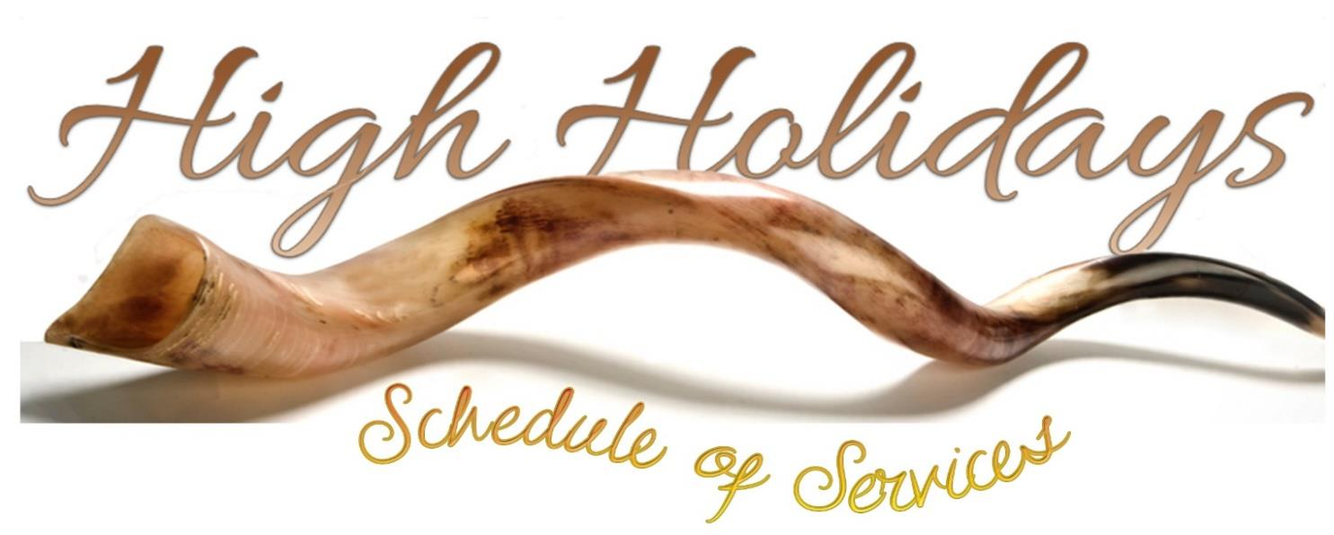
5786/5787
2026

Selichot: Saturday, September 5
Havdalah: 8:30 pm
Followed by Refreshments & a Movie in the Social Hall
Selichot Service: 10:00 pm
IN-PERSON & LIVE on Facebook

Rosh HaShanah: Friday, Sept. 11 to Sunday, Sept. 13
Erev Rosh Hashanah: Friday, September 11, 6:00 pm
IN-PERSON & LIVE on Facebook

Rosh HaShanah Day 1: Saturday, September 12, 10:00 am
IN-PERSON & LIVE on Facebook
Followed by a Congregational Luncheon in the Social Hall

Rosh HaShanah Day 2: Sunday, September 13, 10:00 a.m.
IN-PERSON & LIVE on Facebook

Tashlich: Sunday, September 13, 4:45 p.m.
Brazos Park East, 3516 N. MLK, Jr. Blvd.

Shabbat Shuvah: Saturday, Sept. 19, 10:00 a.m.
IN-PERSON & LIVE on Facebook

Kever Avot: Sunday, September 20, 10:00 am
At the CAJ Cemetery

Yom Kippur: Sunday, Sept. 20 to Monday, Sept. 21
Kol Nidre (Erev Y.K.): Sunday, September 20, 7:00 pm
IN-PERSON & LIVE on Facebook

Yom Kippur Services: Monday, September 21, 2026
Shacharit, 10:00 am; Yizkor, 12:30 pm; Mussaf at 1:30 pm
Mincha & Neilah, 5:30 pm
IN-PERSON & LIVE on Facebook
Followed by a Break-the-Fast Meal at 7:30 pm in the Social Hall

Sukkot: Friday, Sept. 25 to Saturday, October 3
Erev Sukkot: Friday, September 25, 6:00 pm
IN-PERSON & LIVE on Facebook
Followed by Kiddush in the Sukkah

Sukkot Day 1: Saturday, September 26, 10:00 am
IN-PERSON & LIVE on Facebook
Followed by Kiddush & Luncheon in the Sukkah

Erev Yom Tov Sukkot: Friday, October 2, 6:00 pm

Shemini Atzeret & Simchat Torah: Saturday, Oct. 3rd, at 10:00 am
With Yizkor at 11:15 am
IN-PERSON & LIVE on Facebook
Followed by Kiddush & Luncheon in the Sukkah

Order Your Lulav & Etrog Set
Each set includes Etrog, Lulav, myrtles, willows
with a lulav bag

Quality Set $60

Payment is required with order by
Thursday, August 27th by noon.

August Service Schedule

Friday, July 31
Kabbalat Shabbat 6:00 pm
Candle Lighting 8:07 pm
Saturday, August 1
Shacharit 10:00 am
Shabbat Ends 9:04 pm
Friday, August 7
Kabbalat Shabbat 6:00 pm
Candle Lighting 8:02 pm
Saturday, August 8
Shacharit 10:00 am
Shabbat Ends 8:57 pm
Friday, August 14
Kabbalat Shabbat 6:00 pm
Candle Lighting 7:55 pm

Saturday, August 15
Shacharit 10:00 am
Shabbat Ends 8:50 pm
Friday, August 21
Kabbalat Shabbat 6:00 pm
Candle Lighting 7:47 pm
Saturday, August 22
Shacharit 10:00 am
Shabbat Ends 8:42 pm
Friday, August 28
Kabbalat Shabbat 6:00 pm
Candle Lighting 7:39 pm
Saturday, August 29
Shacharit 10:00 am
Shabbat Ends 8:33 pm



August 11
Shayna Via
August 13
Colleen Wolf

August 17
Kathleen Keller
August 19
Judy Hersh
August 19
Aislinn Brooks
August 31
George Keller
Rabbi Lanxner


August 11
Ray & Shayna Via
August 19
Miguel & Lourdes Perez
August 21
Barbara & Darryl Dankenbring

Mazel Tov

Jori Samuel
Bar Mitzvah

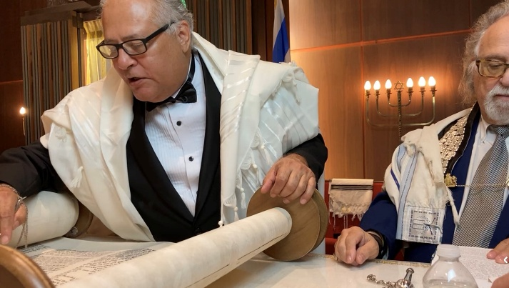

THANK YOU for your donations in July!

Shabbat

Susan Raphael
Steven & Carrie Draher
Inez Bonneville
Jeff Levin Joseph Settle
Susan & Rabbi Lanxner
Henry Hacker

In Memory of

Samuil Godon
Semyon & Anna Papernov
Gita Papernov
Semyon & Anna Papernov

Robert Mitchell
George & Kathleen Keller

Motley Harelik
Harry Harelik
Haskel Harelik
Harry Harelik
Kate Kahan
Richard & Melanie Bauer



YAHRZEITS

The following names of dearly departed will be read aloud by the Rabbi preceding the Mourner’s Kaddish on Shabbat morning. It is fitting and customary that the nearest of kin be present in the synagogue for the recitation of this special prayer in their memory. Attendance not only honors the departed but also enhances and guarantees that a Minyan is present to recite the Kaddish.

Kaddish will be read on July 31
Av 18 Joe Ellis
Av 19 Jacob (Jake) E Gandler*
Alberta E Griffith Howeth
Av 20 Lee David Miller*
Esther Samet*
Charles I Silver*
Ben Tobolowsky*
Av 21 Marilyn Ellis
Mrs. Emma Lynn*
Av 22 Irwin “Buddy” Levy*
Av 23 Abe Berlowitz*
Kaddish will be read on August 7
Av 24 Rachel Aronson*
Violet H Lyons*
Av 25 Rachel (Rae) Levin*
Hildur Metz
Av 28 Israel Chodorow*
Eunice Rosen
Adolph Schein*
Av 29 Sam Aronson*
Gertrude Brickman
Av 30 Helen Marie Hoffman
Mitchell Stein
Sam S Taub*
Kaddish will be read on August 14
Elul 1 A S Kaplan*
Elul 2 Bessie Chodorow*
Nathan Hoffman*
Lilye (Goltz) Silver
Sidney Solomon*
Elul 3 Chester Zeichner
Elul 4 Morris Marcus*
Elul 5 Minnie Rae Fink
Elul 7 Esther Brown*
Jake Aaron Hayman*
Julius Jacobson*

Kaddish will be read on August 21
Elul 8 Dora Berlovitz*
Marthe Bloch Heyman*
Bennie Markusfeld*
Gina Marie Perry-Valusky
Elul 9 Jacob Halpern
Elul 10 Bessie Chernoff*
Isaac Wolpo
Anna Wolstein
Jonas Samuel Zackin
Elul 11 Fannie Lieberman
I (Doc) M Mott*
Elul 12 Mrs. I Adams*
Harry M Dalkowitz
Elul 13 Hannah G Rosenblatt
Elul 14 Pauline Kempler
Louis Kolom*
Nell Miller*
Kaddish will be read on August 29
Elul 15 Pearl Koppman Wise*
Elul 16 Ada Edleman
Dave Greenspan
Rene Kluk
Joe A Novich*
Elul 17 Mrs. Abe (Pearl) Lewis*
Elul 18 Louis Harelik
Mrs. Ben (Fannie T) Kaplan*
Nettie Marcus
Elul 20 Pearl Jacobson*
Johanna Levy*
Elul 21 Charles Harris*

*Plaque on memorial wall.

